Q10. Read the following description of a COBOL program and the program itself, and then answer the sub-question.

[Program Description]
Assume that there is a seminar application file in which applications for seminars are registered. Each individual can apply only once for a seminar, but can apply for up to 10 different seminars. This program flags as an error any application that requests more than one seminar held on the same day, and then prints an error listing.
(1) The record format in the seminar application file is shown below.
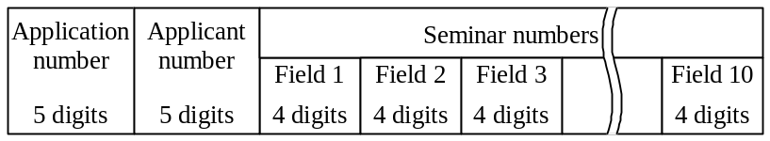
① Assume that the same seminar number will not be specified more than once.
② The seminars being applied for are listed sequentially, starting from field 1; if there are fewer than ten seminars requested, the remaining fields are left empty.
③ Assume that the seminar numbers are stored in the seminar schedule file.
(2) The record format in the seminar schedule file, in which the details of each seminar are registered, is as follows.
Seminar number  4 digits | Scheduled date  8 digits | Room number  10 digits
① This file is an indexed file, using the seminar number as the key.
② All the seminars that are to be held are registered.
(3) The following is an example of the table CHK-TBL that is used by this program to check each application for multiple seminars being held on the same day.

Example: Assume that the following data from the seminar application file and from the seminar schedule file has been provided.
Data from the seminar application file
Data from the seminar schedule file
A001  B002  C003 | 20010411  20010412  20010411 | TORAN-F801  TORAN-F801  TORAN-F802

In this case, the contents of the table CHK-TBL are shown below.
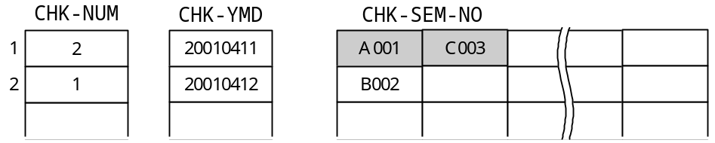
As a result, it is clear that the shaded entries  in the table CHK-SEM-NO, A001 and C003, are held on the same day.
(4) The printing format for the error listing is shown below.
Application Applicant Scheduled Seminar
No. No. date No.
XXXXX XXXXX XXXXXXXX XXXX XXXX XXXX … XXXX
XXXXXXXX XXXX XXXX XXXX … XXXX
XXXXX XXXXX XXXXXXXX XXXX XXXX XXXX … XXXX
⋅ ･⋅ ⋅ ⋅ ⋅ ⋅ ⋅
⋅ ･⋅ ⋅ ⋅ ⋅ ･ ⋅ ⋅
⋅ ･⋅ ⋅ ⋅ ⋅ ･ ⋅ ⋅
XXXXX XXXXX XXXXXXXX XXXX XXXX XXXX … XXXX
XXXXX XXXXX XXXXXXXX XXXX XXXX XXXX … XXXX
① The headings are pre-printed.
② If one application number contains multiple seminars that are held on the same day, all of those seminar numbers are printed on one line.
③ If there are multiple groups of seminars for which ② applies under one application number, the seminars for each day are printed on separate lines. In this case, the application number and the applicant number are printed on the first line, but not on the subsequent lines.
[Program]

DATA DIVISION.
FILE SECTION.
FD APPLY-FILE.
01 APPLY-REC.
02 APP-NO PIC X(05).
02 APP-PSN-NO PIC X(05).
02 APP-SEM-NO OCCURS 10 PIC X(04).
FD SEMINAR-FILE.
01 SEMINAR-REC.
02 SEM-NO PIC X(04).
02 SEM-YMD PIC X(08).
02 SEM-ROOM PIC X(10).
FD CHECK-FILE.
01 CHECK-REC PIC X(85).
WORKING-STORAGE SECTION.
01 INFILE-EOF PIC 9(01) VALUE 0.
01 PRINT-WRK.
02 PRI-NO PIC X(05).
02 PIC X(05).
02 PRI-PSN-NO PIC X(05).
02 PIC X(07).
02 PRI-YMD PIC X(08).
02 PIC X(01).
02 OCCURS 10.
03 PIC X(01).
03 PRI-SEM-NO PIC X(04).
01 CHK-TBL.
02 OCCURS 10.
03 CHK-NUM PIC 9(02).
03 CHK-YMD PIC X(08).
03 CHK-SEM-NO OCCURS 10 PIC X(04).
01 CHK-CNT PIC 9(02).
01 CHK-WK PIC 9(02).
01 CNT1 PIC 9(02).
01 CNT2 PIC 9(02).
01 CNT3 PIC 9(02).
PROCEDURE DIVISION.
MAIN-RTN.
OPEN INPUT APPLY-FILE SEMINAR-FILE OUTPUT CHECK-FILE.
PERFORM UNTIL INFILE-EOF = 1
READ APPLY-FILE AT END
MOVE 1 TO INFILE-EOF
NOT AT END
PERFORM CHECK-RTN
PERFORM PRINT-RTN
END-READ
END-PERFORM.
CLOSE APPLY-FILE SEMINAR-FILE CHECK-FILE.
STOP RUN.
CHECK-RTN.
INITIALIZE CHK-TBL CHK-CNT.
PERFORM VARYING CNT1 FROM 1 BY 1 UNTIL CNT1 > 10
OR APP-SEM-NO (CNT1) = SPACE

READ SEMINAR-FILE INVALID KEY
DISPLAY “Seminar Number Error”
NOT INVALID KEY
PERFORM TABLE-SET-RTN
END-READ
END-PERFORM.
TABLE-SET-RTN.
MOVE 0 TO CNT3.
PERFORM VARYING CNT2 FROM 1 BY 1 UNTIL 
IF SEM-YMD = CHK-YMD (CNT2) THEN

END-IF
END-PERFORM.
IF CNT3 = 0 THEN
COMPUTE CHK-CNT = CHK-CNT + 1
MOVE SEM-YMD TO CHK-YMD (CHK-CNT)
MOVE CHK-CNT TO CNT3
END-IF.
COMPUTE CHK-NUM (CNT3) = CHK-NUM (CNT3) + 1.
MOVE CHK-NUM (CNT3) TO CHK-WK.
MOVE APP-SEM-NO (CNT1) TO CHK-SEM-NO (CNT3 CHK-WK).
PRINT-RTN.
MOVE 0 TO CNT3.
PERFORM VARYING CNT1 FROM 1 BY 1 UNTIL 
MOVE SPACE TO PRINT-WRK
IF  THEN
IF CNT3 = 0 THEN
MOVE APP-NO TO PRI-NO
MOVE APP-PSN-NO TO PRI-PSN-NO
MOVE 1 TO CNT3
END-IF
MOVE CHK-YMD (CNT1) TO PRI-YMD
PERFORM VARYING CNT2 FROM 1 BY 1
UNTIL CNT2 > CHK-NUM (CNT1)

END-PERFORM
WRITE CHECK-REC FROM PRINT-WRK AFTER 1
END-IF
END-PERFORM.

Sub-question
From the answer groups below, select the correct answers to be inserted in the boxes  in the program.

Answer group for “a” and “c”:
a) MOVE CNT1 TO CNT2 b) MOVE CNT1 TO SEM-NO
c) MOVE CNT2 TO CNT1 d) MOVE CNT2 TO CNT3
e) MOVE CNT2 TO SEM-NO f) MOVE CNT3 TO CNT1
g) MOVE CNT3 TO CNT2 h) MOVE APP-SEM-NO TO CNT1
i) MOVE SEM-NO TO PRI-SEM-NO (CNT1)
j) MOVE APP-SEM-NO (CNT1) TO SEM-NO

Answer group for “b” and “d”:
a) CHK-CNT > CNT1 b) CHK-CNT > CNT2
c) CHK-CNT > CNT3 d) CHK-NUM (CNT1) > CNT2
e) CHK-NUM (CNT2) > CNT3 f) CNT1 > CHK-CNT
g) CNT2 > CHK-CNT h) CNT2 > CHK-NUM (CNT1)
i) CNT3 > CHK-CNT j) CNT3 > CHK-NUM (CNT2)

Answer group for “e”:
a) CHK-NUM (CNT1) > 1 b) CHK-NUM (CNT1) > CNT1
c) CHK-NUM (CNT3) > 1 d) CHK-NUM (CNT3) > CNT3
e) CNT1 > 1 f) CNT3 > 1

Answer group for “f”:
a) MOVE CHK-SEM-NO (CNT1 CNT2) TO PRI-SEM-NO (CNT1)
b) MOVE CHK-SEM-NO (CNT1 CNT2) TO PRI-SEM-NO (CNT2)
c) MOVE CHK-SEM-NO (CNT1 CNT3) TO PRI-SEM-NO (CNT3)
d) MOVE CHK-SEM-NO (CNT2 CNT1) TO PRI-SEM-NO (CNT1)
e) MOVE CHK-SEM-NO (CNT2 CNT1) TO PRI-SEM-NO (CNT2)
f) MOVE CHK-SEM-NO (CNT2 CNT3) TO PRI-SEM-NO (CNT2)

